Brief Report for Assignment 1C

Hao Liu

In the main.c , I first created a array of int numbers( for data) and a array of double numbers (for keys). Given these two arrays value:

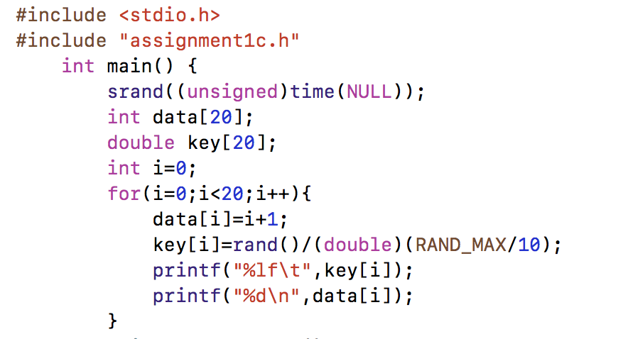

Then used the function and structs I defined in head files to deal with these data:

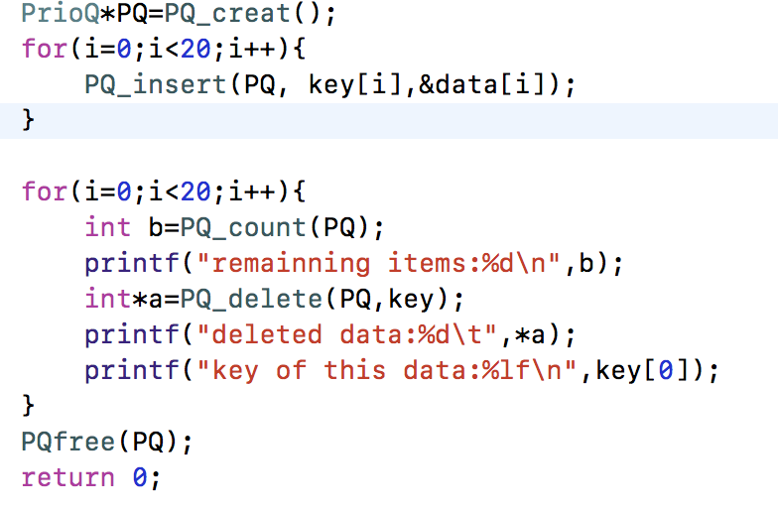

Result is showed as follow: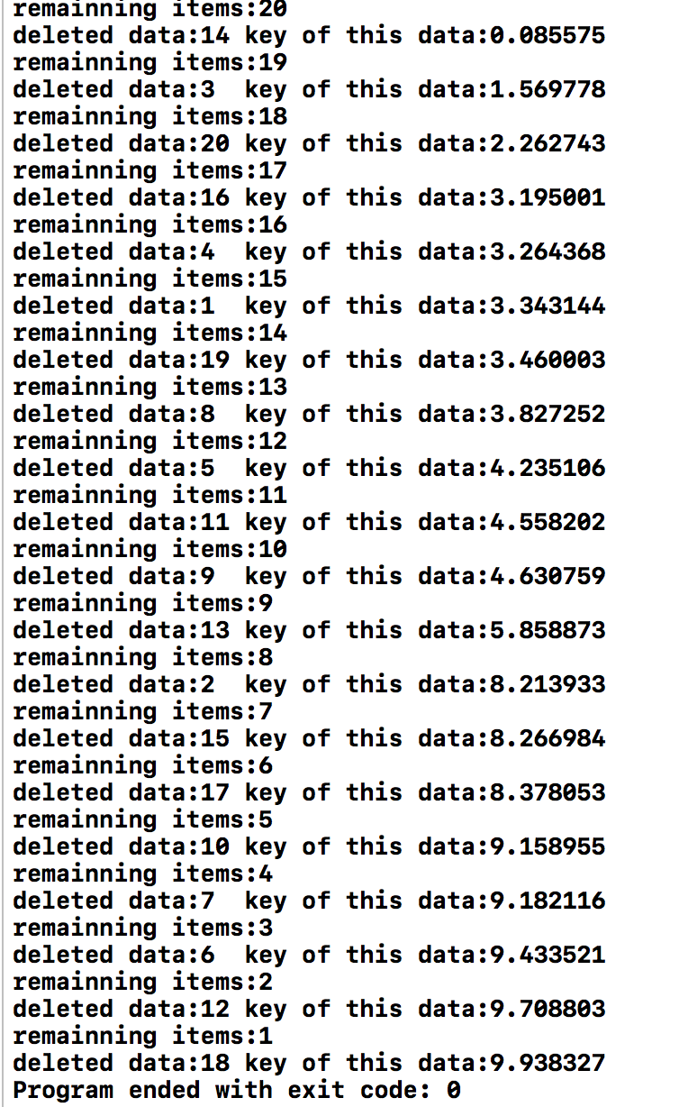

Then I changed the data type to double , did the same thing as before:

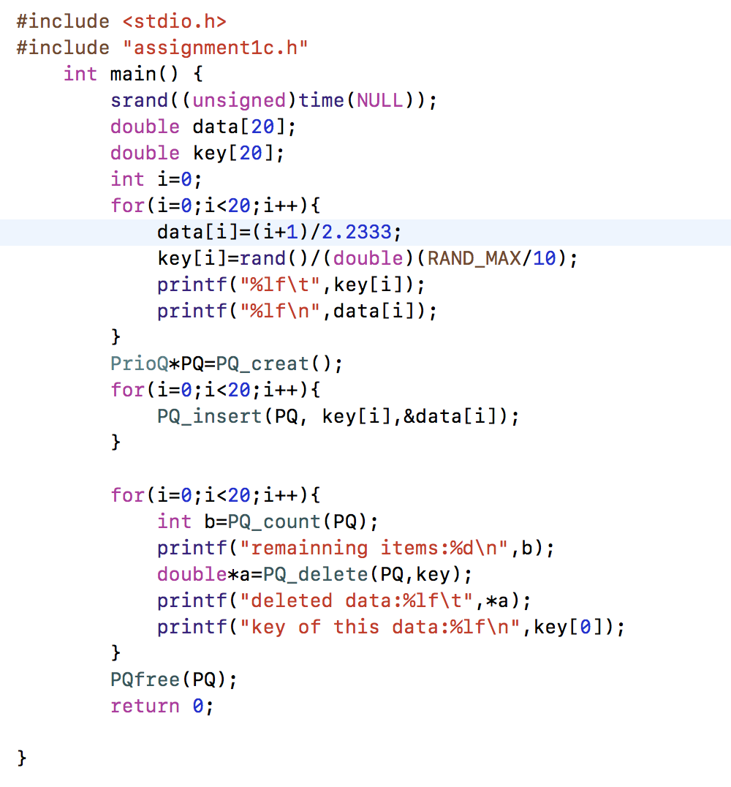

Result is showed as follow:

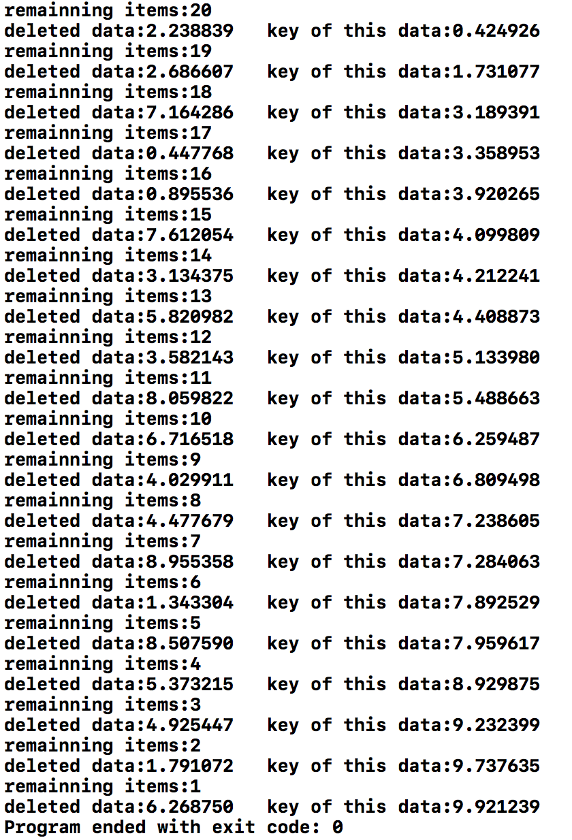

As we can see, this software can be used in any type of data, and it will function correctly, the key of deleted nodes are always bigger than former key.